Recruitable Resource: Equity

Understanding the difference between equality and equity can be really confusing, particularly as it relates to recruitment processes. Questions like, “Does the interview process need to be the same for everyone? If I make changes for some, isn’t that discrimination?” can be common.

The short answer to these questions is no, if you are making changes for people to support them to achieve an equal outcome, it isn’t discrimination, it is equity.

It may seem that by creating the same process for everyone, you are creating an equal process. However, this approach won’t necessarily take into account people’s individual circumstances, and they may miss out as a result.

In fact, it can be indirect discrimination to require everyone to go through the same process if that process disadvantages some people over others.

Equality
Equality is looking to provide the same resources, opportunities and systems for all people, regardless of their circumstnaces.

Equity
Equity is looking to provide resources, opportunities and adjustments to systems based on individual circumstances, in order to offer equal opportunity to meet an equal outcome.

Indirect discrimination
Indirect discrimination is when there’s a practice, policy or rule which applies to everyone in the same way but disadvantages some people more than others.
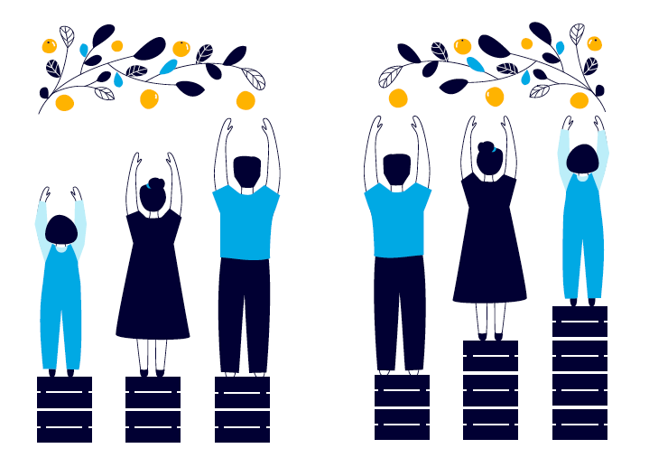
Illustration one depicts equality, Illustration two shows equity

Providing the adjustments people need to present as the best version of themselves at an interview or during employment is not discrimination. It will give your organisation the best chance of finding the right person for the job.

Be a part of the bigger picture
and learn how to be more inclusive
of people with disability with the Recruitable resources.

