Recruitable Resource: Models of Disability

The Medical Model of disability

In this definition a disability can be, but not limited to; physical, non-physical, sensory, intellectual, neurological. A disability may be visible or non-visible, may be permanent or temporary and may have minimal or substantial impact on a person’s abilities.

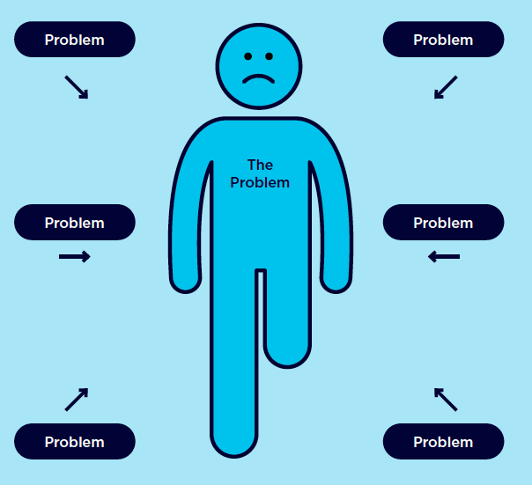

The medical model places ‘the problem’ of disability and limited accessibility on the individual.

Impairments and chronic illness often pose real difficulties but they are not the main problems.

Views of the medical model of disability

Disability is caused by physical, mental, and sensory impairment. The individual is impaired and is the problem. Disability is a medical issue where impairments need to be cured or have their effects alleviated.

The Social Model of disability
The social model of disability holds a more contemporary view, and defines disability as the result of interactions between people with disability and a society where physical, attitudinal, communication and social barriers exist.

The social model of disability acknowledges that the issue of poor accessibility is a societal problem, not an individual one.
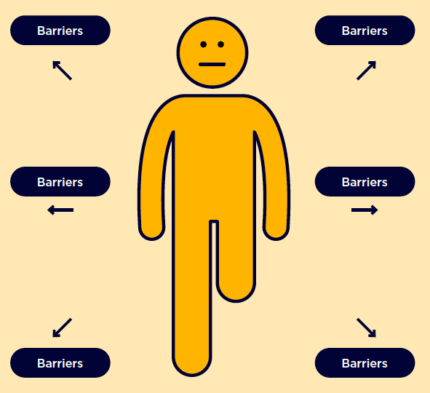

Views of the social model of disability
Environments are inaccessible, this can be through buildings, language, services and communication. The Individual receives prejudice, stereotyping and discrimination against them. Organisations are inflexible in their procedures and practices.

Be a part of the bigger picture
and learn how to be more inclusive
of people with disability with the Recruitable resources.

